Photoshop CS5 Toolbox User Guide
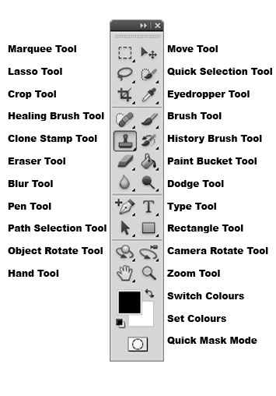

Move Tool – You can use the Move tool to copy selections as you drag them within or between images, or you can copy and move selections using the Copy, Copy Merged, Cut, and Paste commands. Dragging with the Move tool saves memory because the clipboard isn’t used.

Marquee Tool –

Quick Selection Tool –

Lasso Tool –

Eyedropper Tool –

Crop Tool –

Brush Tool –

Healing Brush Tool –

History Brush Tool –
Clone Stamp Tool –

Paint Bucket Tool –

Eraser Tool –

Dodge Tool –

Blur Tool –

Type Tool –

Pen Tool –

Rectangle Tool –

Path Selection Tool –
Camera Rotate Tool –

Object Rotate Tool –

Zoom Tool –

Hand Tool –

Switch Foreground/Back ground Colours –

Set Foreground/Back ground Colours –

Quick Mask Mode -

